CPE301 – SPRING 2020

Midterm 1

Write, simulate and demonstrate using Atmel Studio 7 a C code for the AVR ATmega328p/pb microcontroller that performs the following functions:

1. Program the UART Module to interact with the ATmega328p/pb:
2. On transmitting the following keys from the host terminal, the following actions will be performed:
   1. On-reboot or ‘h’ key – help screen (list all keys and functionalities)
   2. ‘t’ display temperature in C of LM34/35 on terminal, ‘T’ – display temperature in F of LM34/35 on terminal.
   3. ‘o’ turns ON LED at PB5, ‘O’ turns OFF the LED at PB5.
   4. ‘s’ sends a string to the terminal
   5. ‘i’ sends an integer to the terminal. Use the integer as a delay in seconds to blink the LED PB2.
3. **COMPONENTS LIST AND CONNECTION BLOCK DIAGRAM w/ PINS**

ATmega328PB Xplained mini USB cable Atmel Studio 7

Data Visualizer LM35 sensor Breadboard

Multifunction shield

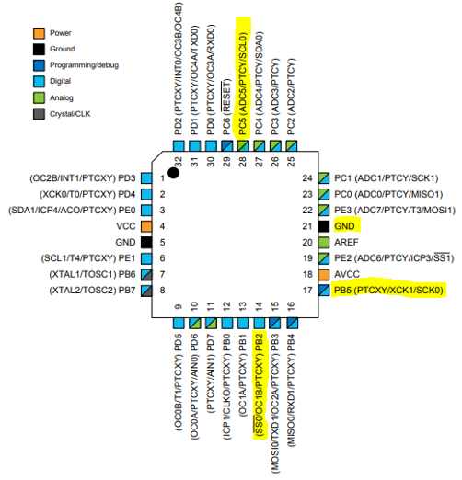

Wires connected to:  
PC5, GND, 5V

1. **INITIAL/MODIFIED/DEVELOPED CODE OF TASK 1/A**

There’s only 1 task, but there’s multiple requirements for that.

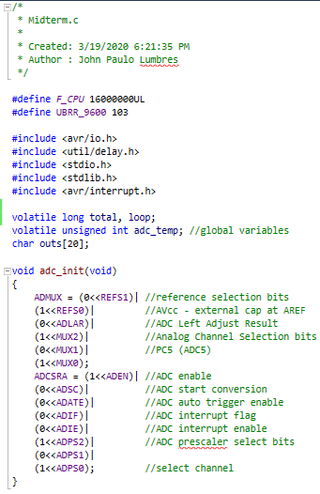

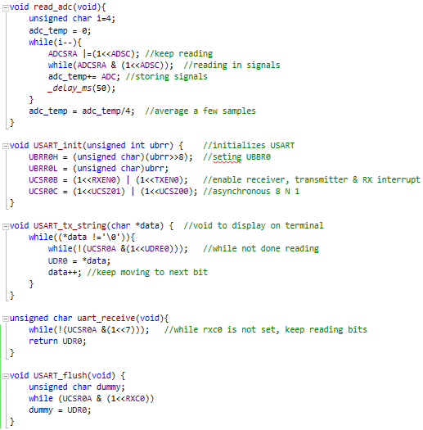

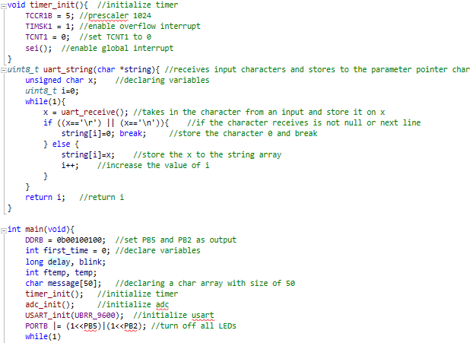

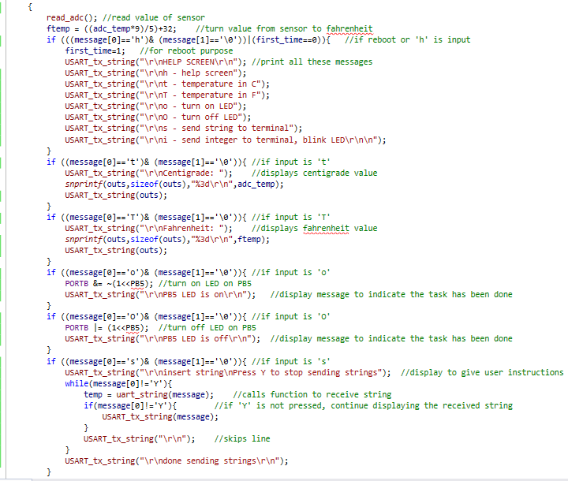

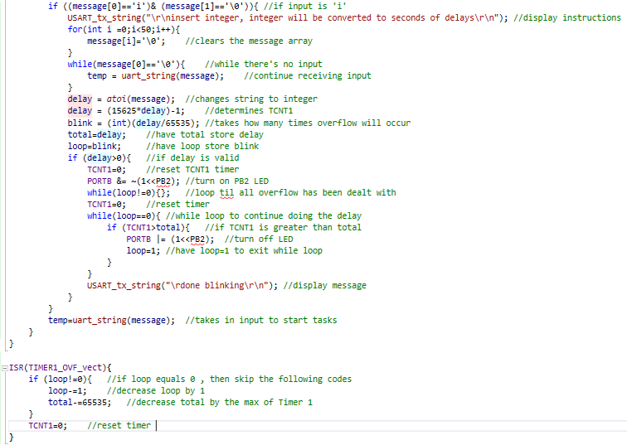

1. **SCHEMATICS**

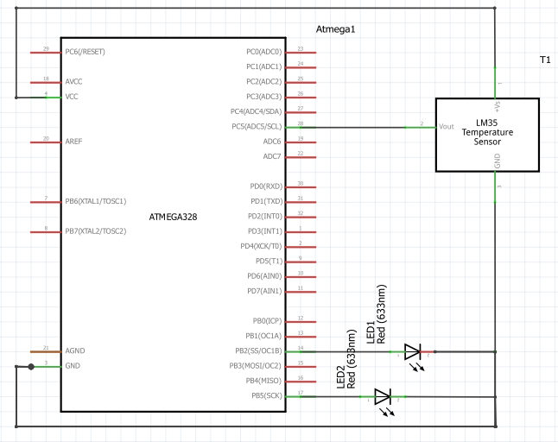

1. **SCREENSHOTS OF EACH TASK OUTPUT (ATMEL STUDIO OUTPUT)**

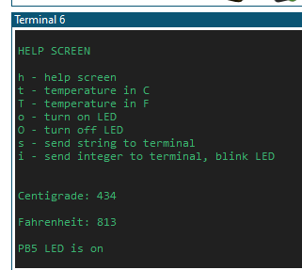

When ‘h’ is pressed or on reboot

When ‘o’ is pressed

When ‘T’ is pressed

When ‘t’ is pressed

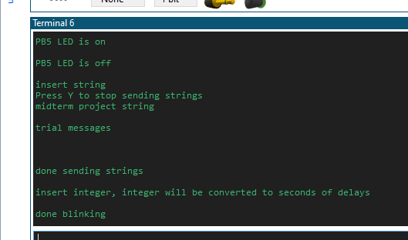

When ‘s’ is pressed

When ‘i’ is pressed

When ‘O’ is pressed

1. **SCREENSHOT OF EACH DEMO (BOARD SETUP)**

The sensor starts heating up fast when I tried plugging it in the multi-function shield, so in order to prevent issues from happening, I used a breadboard to connect the sensor instead.

The values might look high because the connections sometimes gets loose, but it works because it is the same setup as done on DA3B. The demo vid has lower values if you need to check.

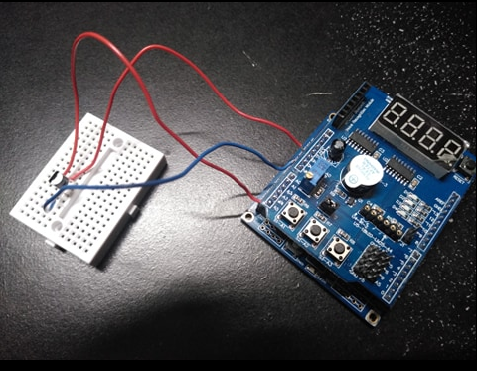

For turning on PB5 LED For blinking PB2

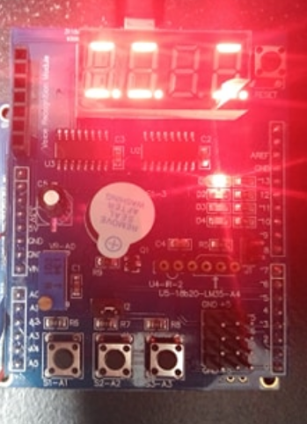 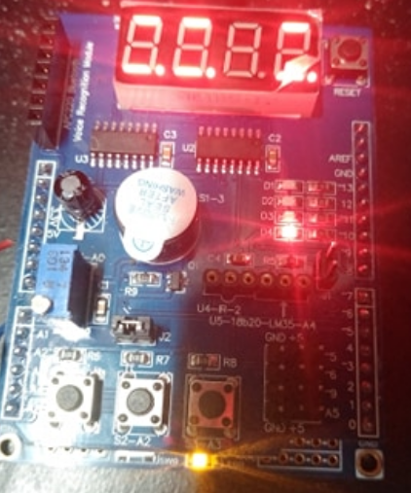

1. **VIDEO LINKS OF EACH DEMO**

<https://youtu.be/ZPpPr1tTiAc>

1. **GITHUB LINK OF THIS DA**

<https://github.com/lumbrj1/submission/tree/master/Midterms>

**Student Academic Misconduct Policy**

<http://studentconduct.unlv.edu/misconduct/policy.html>

“This assignment submission is my own, original work”.

John Paulo Lumbres